**Review Package #1- The Material World**

**1. Volume:** page 22

|  |
| --- |
| **Definition**:  ______________________________________________________________________________________________________________________________________________________________________________________________________________________________________________________  **Units:** ____________________________________________________________________________ |

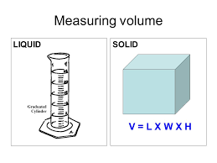

**2. Temperature**: page 29

|  |
| --- |
| **Definition:**  ________________________________________________________________________________________________________________________________________________________________  ________________________________________________________________________________ |

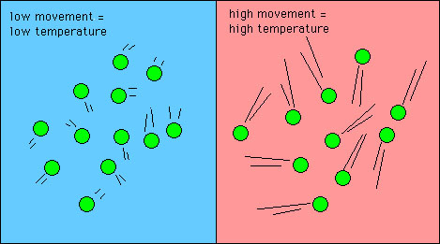

**3. Acids and Bases:** page 34

|  |  |  |
| --- | --- | --- |
| **Acids** | **Bases** | **Neutral** |
| Has a pH ______ 7 | Has a pH ______ than 7 | Has a pH ________ to 7 |
| Turns litmus paper____ | Turns litmus paper ______ | Does ____ change the colour of litmus paper. |

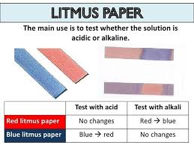

**4. Mixtures:**  page 49

|  |
| --- |
| **Homogeneous:**  ____________________________________________________________________________________________________________________________________________________________________  **Heterogeneous:** __________________________________________________________________________________  __________________________________________________________________________________ |

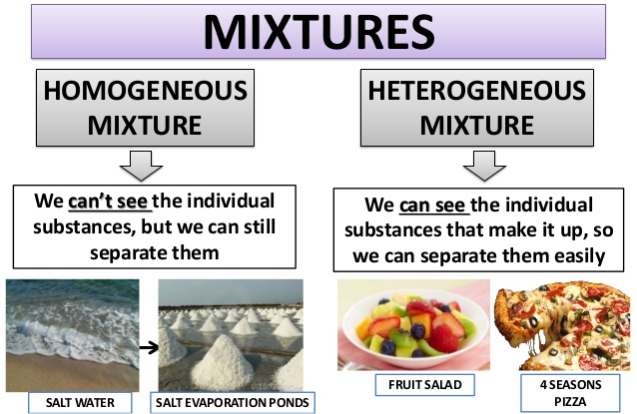

**5. Changes of State (Phase changes):** page 8

|  |
| --- |
| **Definition:**  __________________________________________________________________________________________________________________________________________________  __________________________________________________________________________________________________________________________________________________ |

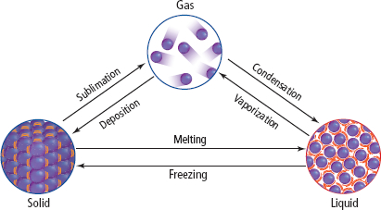

**6. Phase Change Diagram:** Page 10

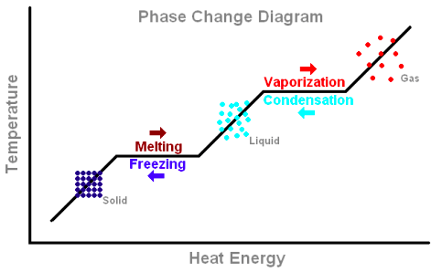

Réchauffement du gaz

Vaporisation

Réchauffement du liquide

Réchauffement du solide