Review Document #3 – Earth and Space

1. The Internal Structure of The Earth - Page 152

2. Eclipses: page 217
Definition
______________________________________________________________________________________________________________________________________________
During a solar eclipse: _________________________________________________
During a lunar eclipse: ________________________________________________

___________Eclipse __________________ Eclipse

3. Layers of the Atmosphere- Page 168

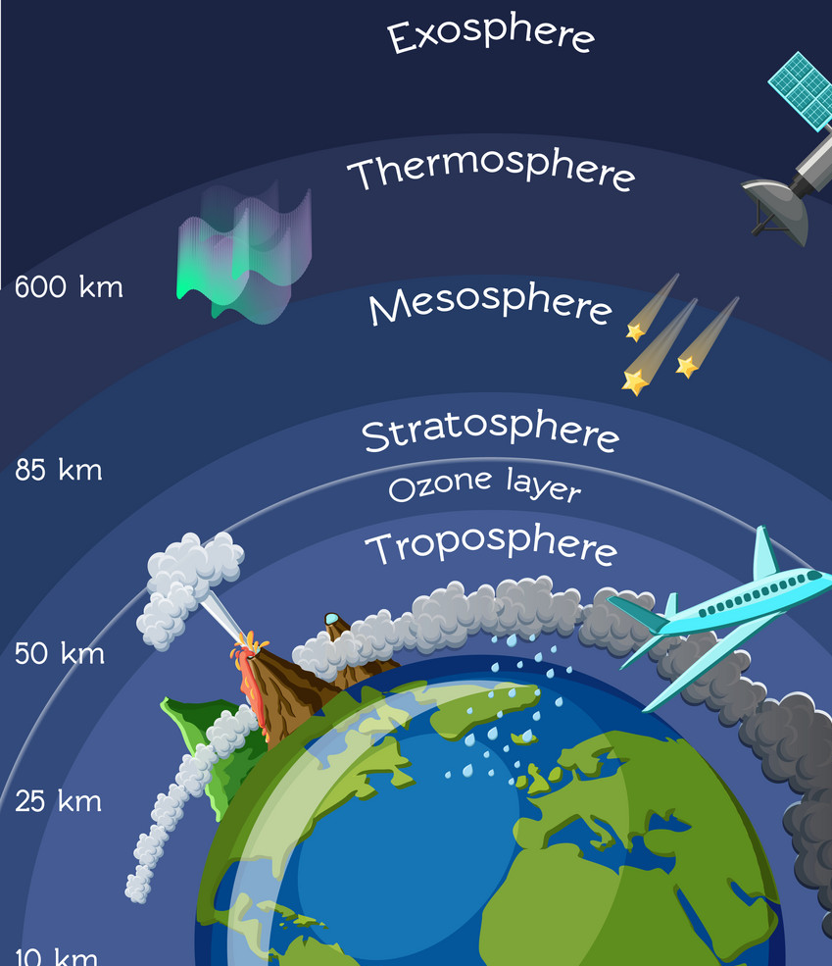

4. The distribution of Fresh Water : Page 164

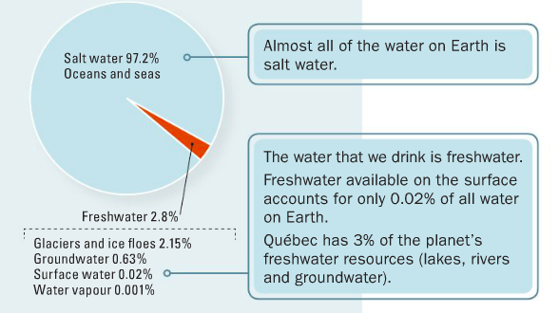

5. Tectonic Plates: Page 177

Definition
______________________________________________________________________________________________________________________________________________
______________________________________________________________________________________________________________________________________________

Movement | Name | Geological Phenomenon
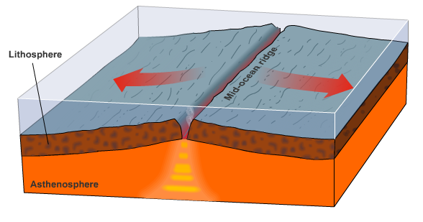 | Divergent Boundary (Move apart) | Mid-oceanic ridges
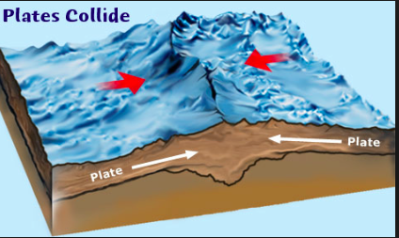  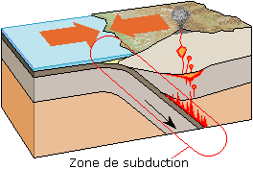 | Convergent Boundary (Collide) | 2 continental plates = Orogenesis  1 continental plate and 1 oceanic plate = Subduction zone (VOLCANOS)
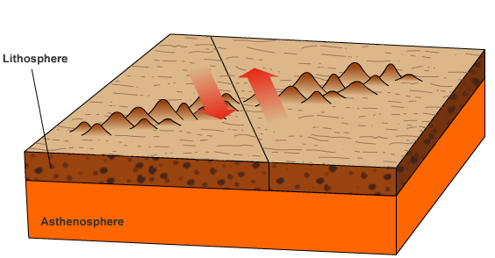 | Transform Boundary (Rub together) | Earthquakes

6. The Seasons - Page 209

7. Erosion: page 192
Definition
______________________________________________________________________________________________________________________________________________
______________________________________________________________________________________________________________________________________________

Erosion by __________ Erosion by __________
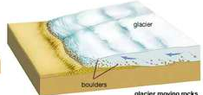
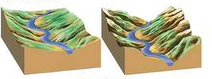

Erosion by ___________ Erosion by ___________
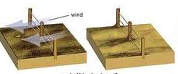
8. The Water Cycle
: Page 173
