**Review Package #4- Technological World**

1. For each statement below, write the letter of the effect of the force described.

Shearing Bending Compression

Tension Torsion

**A**

**B**

**C**

**D**

**E**

a) A spiderweb fixed to the ceiling and a spider   
hanging from the other end

b) Flattened car bodies stacked on top of each other   
in a junkyard

c) A slice being cut from a loaf of bread

d) A cloth being wrung out

e) The string of a bow being drawn

1. Consider the illustration opposite, then answer the questions.

a) Indicate the motions performed by the handle and   
levers when the tip of a corkscrew is inserted into   
a cork.

|  |  |
| --- | --- |
| Handle: |  |
| Levers: |  |

b) What motion does the corkscrew blade   
make when the levers are pushed down?

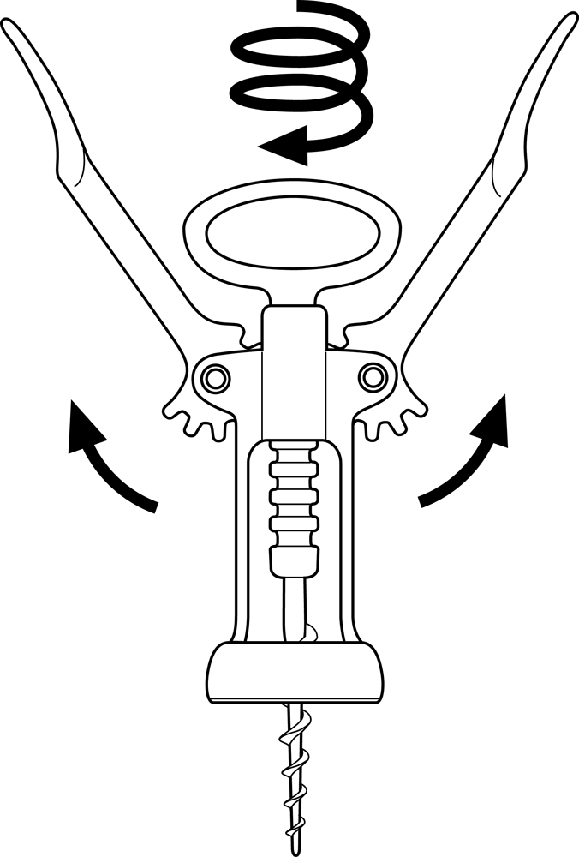

|  |
| --- |
|  |

1. Fill in the table by writing the meaning of each symbol and checking  
   the appropriate column.

|  |  |  |  |  |  |  |  |  |
| --- | --- | --- | --- | --- | --- | --- | --- | --- |
| **SYMBOL** |  | **MEANING** | | |  | **MOTION** | **EFFECTS OF FORCE** | **GUIDING CONTROL** |
| u1_eval7_q5_image1 |  | |  |  | | □ | □ | □ |
|  | |  |  | |
|  | |  |  | |
| u1_eval7_q5_image2 |  | |  |  | | □ | □ | □ |
|  | |  |  | |
|  | |  |  | |
| u1_eval7_q5_image3 |  | |  |  | | □ | □ | □ |
|  | |  |  | |
|  | |  |  | |
| u1_eval7_q5_image4 |  | |  |  | | □ | □ | □ |
|  | |  |  | |
|  | |  |  | |
| u1_eval7_q5_image5 |  | |  |  | | □ | □ | □ |
|  | |  |  | |
|  | |  |  | |
| u1_eval7_q5_image6 |  | |  |  | | □ | □ | □ |
|  | |  |  | |
|  | |  |  | |
| u1_eval7_q5_image7 |  | |  |  | | □ | □ | □ |
|  | |  |  | |
|  | |  |  | |

1. Check the removable link.

□ The link between the legs and seat of a chair

□ The link between a stapler and its plastic shell

□ The link between a door and its handle

□ The link between a mug and its handle

1. True or false?

TRUE FALSE

a) When a person sits on a cushion, □ □  
it experiences tension.

b) Helical motion is a combination of □ □  
two types of translational motion.

c) The blades on a pair of scissors rotate □ □  
because of a rivet.

d) A guiding control is a device that links □ □  
stationary parts.

e) Translational motion always occurs in □ □

1. Name the type of guiding control present in each object.

a) A syringe



b) A cover



c) A telescopic ladde



1. Check the statement that best fits the definition of a material.

□ A material is a substance that an object is made of.

□ A material is an object that helps assemble, modify, polish   
 or cut the parts of another object.

□ A material is a substance in its original state that is used   
 to make an object.

□ A material is a mineral substance that an object is made of.

1. Indicate whether each technical object is animal-based, plant-based or mineral-based.

ANIMAL- PLANT- MINERAL-   
 BASED BASED BASED

a) A steel hammer □ □ □

b) A leather jacket □ □ □

c) A linen shirt □ □ □

d) A pine board □ □ □

e) A marble statue □ □ □

f) A bamboo board □ □ □

1. You used the following objects to build a small wooden car.

|  |  |
| --- | --- |
| * Cotton string * A screwdriver * A wooden board * Rubber bands * Iron rods * A hacksaw | * Nails * A wood saw * Plastic washers * A drill * A hammer * Screws |

a) Which of these objects are equipment?

|  |
| --- |
|  |
|  |

b) Name the three raw materials of the list.

|  |  |  |  |  |
| --- | --- | --- | --- | --- |
|  |  |  |  |  |

1. Draw the appropriate force and motion symbols in the labels of the illustrations.

u1_eval8_q6_image1

Rivets

Levers body

Extraction jaws   
(wedge-shaped   
pair of points)