Review Package #2- Living World
- Check the characteristic that is not a common criteria shared by individuals
of the same species.
□ They can reproduce together. □ Their offspring can reproduce
together.
□ Their offspring are sterile. □ They look alike.
- Check the statement that is true.
□ The term “population” describes all of the members of a species.
□ The term “species” describes the number of individuals in a population.
□ The term “species” covers one or more populations. The term “population”
describes the number of individuals in a species that live in a given territory.
□ The term “species” describes the number of individuals in a population living
in a given territory. The term “population” can cover several species at once.

- Check the characteristic that does not describe an animal's habitat.
□ Geographic location □ Climate
□ Human presence □ Relief
□ Competition with other species □ Flora
□ Presence of water □ Fauna
- Check the statement that describes one of gazelles’ physical adaptations.
□ Gazelles travel in groups to improve their chances of survival.
□ Gazelles’ stomachs have several compartments, allowing the
animals to graze.
□ Gazelles leap to escape from predators.
□ Gazelles rest under trees when it gets hot
- Check the statement that is not a behavioural adaptation.
□ Gulls follow farmers working in the fields so they can eat the worms the farmers unearth.
□ Hares freeze when they hear sudden noises.
□ Squirrels climb trees to escape predators.
□ Chameleons have suction cups on their feet so they can better grip trees.

- Check the statement that is not a characteristic of a living thing.
□ It reproduces. □ It has exchanges with its environment.
□ It requires energy. □ It is made up of many cells.
□ It reacts to stimuli. □ It adapts to changes in its environment.
- What cell component am I?
/10
a) I give plants their stiffness.
b) I control the cell’s activities.
c) I use respiration to produce
the energy that the cell needs
to function.

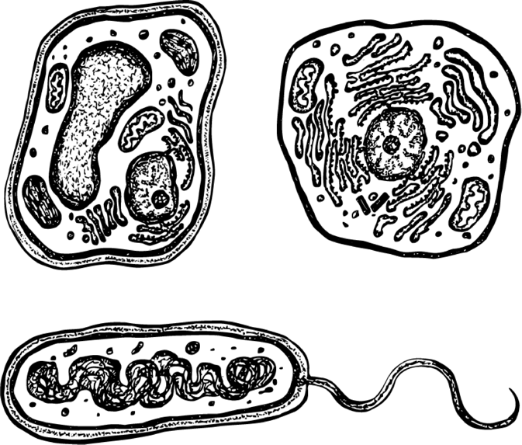
- Consider the following illustrations.
B
A

a) Name the components labelled in the illustrations.
b) Check the right description.
□ Cells A and B are animal cells.
□ Cells A and B are plant cells.
□ Cell A is an animal cell and Cell B is a plant cell.
□ Cell A is a plant cell and Cell B is an animal cell.

- True or false?
TRUE FALSE
a) Asexual reproduction favours a species’ □ □
adaptation and evolution.
b) Asexual reproduction allows a species □ □
to increase a population quickly.
c) Sexual reproduction produces offspring □ □
identical to the parents.

- Once the female has been fertilized, the offspring can develop in one of three ways…

